How many hours do you estimate you spent completing the assignment? 15 hours

What was easiest? Adding comments to all the HTML explaining functionality

What was most difficult? Incorporating JS variables into the URL and having them load from the mustache template

Discuss how you incorporated the feedback you received from the Week 4 peer feedback and heuristic evaluation into your final project. Tell me what feedback was included in your final design, and provide specific examples. Please write at least two paragraphs explaining the changes you made.:

Overall, the peer feedback and heuristic evaluation process was critical for soliciting valuable feedback for the Renda site. I was able to address all the feedback received during week 4 and change my website accordingly to address the concerns. The first feedback I got from the discussions during week 4 was addressing how my website will scale on smaller viewports such as when the screen is scaled down or when the website is being viewed on a mobile device. A suggestion was provided to potentially incorporate a hamburger type navigation that would be able to be collapsed when the viewport was scaled down. I was able to incorporate this hamburger navigation using CSS media queries. The media query collapses the main logo, search bar and navigation menu to a condensed navigation bar consisting of a hamburger collapse button under 1200px screen width. When the hamburger button is clicked the menu activates, showing the categories and new posting button vertically. This ensures that the website will scale appropriately on smaller viewports. In addition, the three column image tile layout auto scales and collapses down to one column at smaller widths.

Width >=1200 px



Width<1200px



Hamburger menu expanded:



The next feedback I received was the action that occurred after pressing the post button on the post item page. Beforehand, it would not give any system status as to whether the post action was successful or not and instead take the user right to the home page. Now, I have a JS alert that pops up after clicking the post button that communicates the post status, as shown below. After the user clicks “OK”, the system then redirects to the home page.

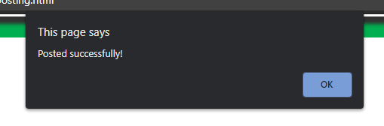

Similar to the post status, the next feedback I received was regarding login status. After a user logs into the website, before the site would not give any alert. Now I included a login successful alert as shown below

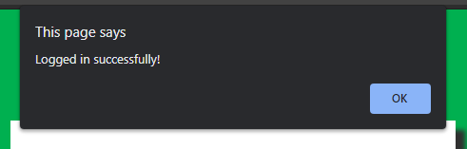

Next, I received feedback stating that there was no description on the home page as to what the site was about. I initially thought of keeping it simple with just the pictures of the items on the home page, but for a person unfamiliar with the site they might be confused as to what the sites’ purpose is. I solved this issue by incorporating a one sentence description at the top of the home page shown below.

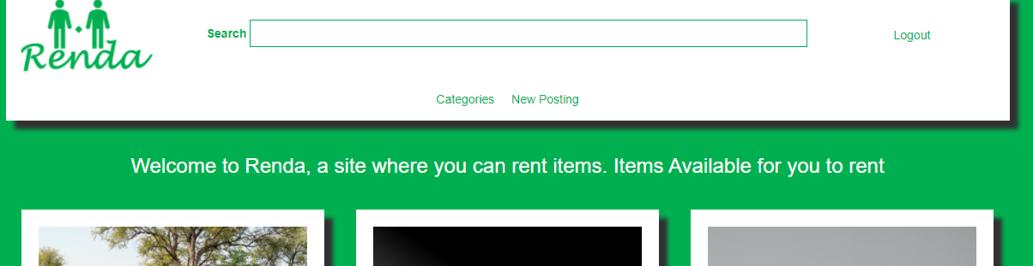

Next, I received feedback suggesting that I place social media sharing buttons on the site to help promote the site and its’ content. I did this by placing the social media links in the footer of the site as shown below, which is present across all the pages



Finally, I received feedback stating that the clear button form was missed on the contact us page, which indeed was missing. I solved this by adding the clear button as shown below

